Project Design Phase-II
Data Flow Diagram & User Stories

Date | 15 October 2026
Team ID | Roll 58
Project Name | EV Market Analysis Dashboard using Tableau Public
Maximum Marks | 4 Marks

Data Flow Diagrams:
A Data Flow Diagram (DFD) is a traditional visual representation of the information flows within a system. A neat and clear DFD can depict the right amount of the system requirement graphically. It shows how data enters and leaves the system, what changes the information, and where data is stored.
DFD Symbol Legend
Symbol | Name | Description
Oval / Rounded  shape | External Entity | A person, organization, or system outside the project that sends or receives data (e.g., Customer, Payment Gateway).
Rectangle with  numbered header | Process | An activity that transforms incoming data into outgoing data (e.g., Validate Request, Process Order).
Rectangle (solid fill, no number) | Data Store | A place where data is held for later use (e.g., Customer Database, Inventory).
Labeled arrow | Data Flow | The movement of data between entities, processes, and data stores, labeled with what data is being passed.

Example: DFD Level 0 (Industry Standard)

EV MARKET ANALYSIS — DATA FLOW DIAGRAM (LEVEL 0)
The diagram shows how the supplied EV dataset is loaded, checked, prepared, analyzed, and presented to dashboard users.
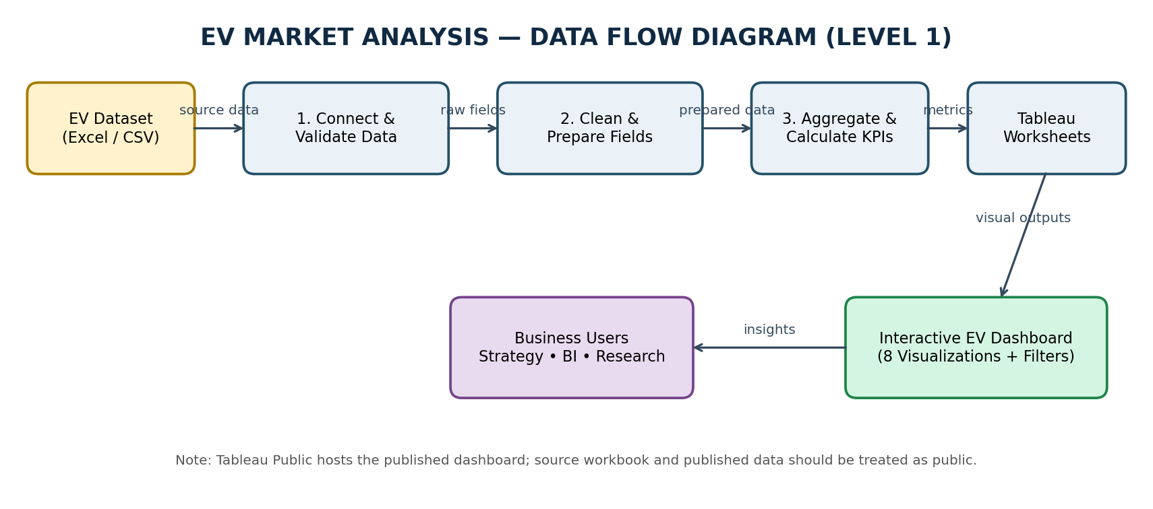
Data flow summary: Excel/CSV source → connect and validate → clean and prepare fields → aggregate sales and calculate metrics → Tableau worksheets → interactive dashboard → strategy, business intelligence, and research users.
User Stories
Use the below template to list all the user stories for the product.
User Type | Functional Requirement (Epic) | User Story Number | User Story / Task | Acceptance criteria | Priority | Release
Market Strategy Director | Market Performance Analysis | USN-1 | As a strategy director, I want to compare annual sales by manufacturer so I can identify leading brands. | Manufacturer bars display SUM(annual_sales_units) in descending order. | High | Sprint 1
Market Strategy Director | Category Analysis | USN-2 | As a strategy director, I want to compare sales by vehicle category so I can prioritize product segments. | Each category shows aggregated sales with a clear title and labels. | High | Sprint 1
Business Intelligence Manager | Battery Analysis | USN-3 | As a BI manager, I want to view battery technology distribution so I can understand technology adoption in the supplied dataset. | Battery types are grouped and counted using distinct vehicle IDs or model names. | High | Sprint 1
Research Analyst | Range Analysis | USN-4 | As a researcher, I want to compare average driving range by category so I can assess differences between vehicle segments. | AVG(range_km) is shown by category; null range values are excluded. | High | Sprint 1
Business Intelligence Manager | Price / Range Comparison | USN-5 | As a BI manager, I want to compare price and range so I can identify vehicles offering a useful balance of cost and range. | Scatter plot maps price_usd to range_km and distinguishes categories by color. | Medium | Sprint 2
Research Analyst | Customer Satisfaction | USN-6 | As a researcher, I want to compare customer ratings by manufacturer so I can explore satisfaction patterns. | Average rating is displayed by manufacturer; null ratings are excluded. | Medium | Sprint 2
Business Intelligence Manager | Geographical Analysis | USN-7 | As a BI manager, I want to compare EV manufacturing countries so I can understand the geographic distribution of records or sales. | Country view uses a valid country field and clearly states whether it counts records or sums sales. | Medium | Sprint 2
Market Strategy Director | Year Analysis | USN-8 | As a strategy director, I want to compare sales by model year so I can see how recorded sales differ across model years. | Line chart aggregates sales by model_year and is labelled as model-year comparison, not confirmed historical sales trend. | Medium | Sprint 2
All dashboard users | Interactive Dashboard | USN-9 | As a dashboard user, I want to filter the visuals by manufacturer, category, battery type, country, and model year where available. | Filters update applicable charts and selected charts can filter related views. | High | Sprint 2
Dashboard Developer | Data Quality | USN-10 | As a developer, I want missing values and data types checked so that dashboard metrics are interpreted correctly. | Numeric fields use numeric data types and missing values are reviewed before publishing. | High | Sprint 1

